# Workshop: Azure Deployment

Workshop for the ["ASP.NET Advanced" course @ SoftUni](https://softuni.bg/trainings/3854/asp-net-advanced-october-2022)

The "House Renting System" **ASP.NET Core MVC App** is a Web application for **house renting**. Users can look at **all** **houses** with their **details**, **rent a house** and look at **their rented houses**. They can also **become** Agents. Agents can **add houses**, see their **details** and **edit** and **delete** only **houses they added**. The Admin has **all privileges** of Users and Agents and can see **all registrations** in the app and **all made rents**.

We have implemented the web application during the workshops in the course. Now it's time to deploy the app.

## Create an Account in Azure

To create an account in Azure, you need to follow a few steps:

1. Go to <https://azure.microsoft.com/en-us/>.
2. Click on the **[Free account] button**



1. Then click on the **[Start free]** button

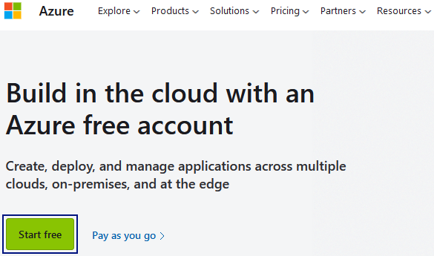

1. Type in your **SoftUni student e-mail** and click on the **[Next]** button

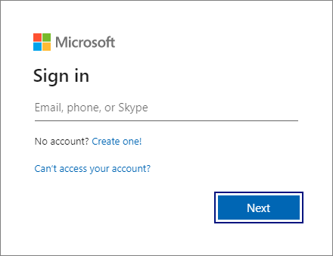

In the next window you should type in your password and click on the **[Sign in]** button. You will be asked to if you want to stay signed in – chose your preference and click on the **[Yes]** or **[No]** button.

In case you have logged in previously with your account, you should see this window. Just click on the **[Sign in]** button or if you'd like to change the e-mail address, click on [**Sign in with another account]**.

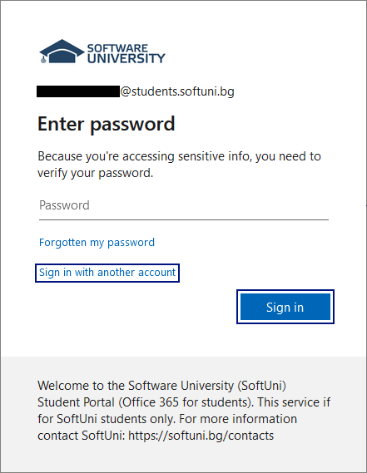

If you have chosen to sign in with another account, you should see the window below. Chose the account you want to sign in with and click on it.

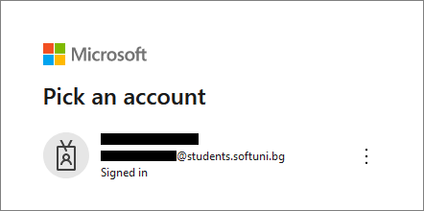

1. You will be asked for your personal information, such as name, address, credit card (please read the conditions for the trial period)
2. Press Sign Up button.

## Deploy a Project in Azure

In this demo we will go over the process of deploying a project in Azure. We will deploy the **House Renting System** project, that we have been developing through this course.

### Step 1: Configure App Service

Right click on the project in Solution Explorer → **Publish**

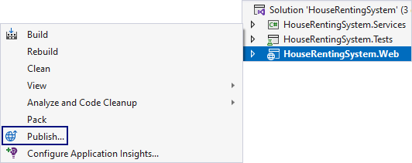

Then, you choose the **Azure** option and click **[Next]**:

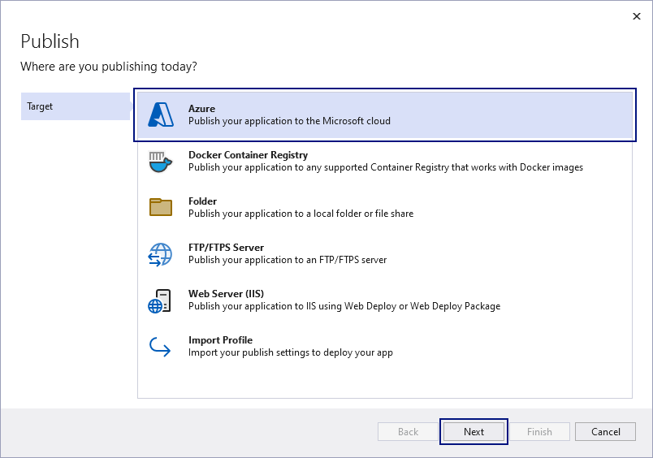

In the next step, you can choose a different service to host your application and click on the **[Next]** button.

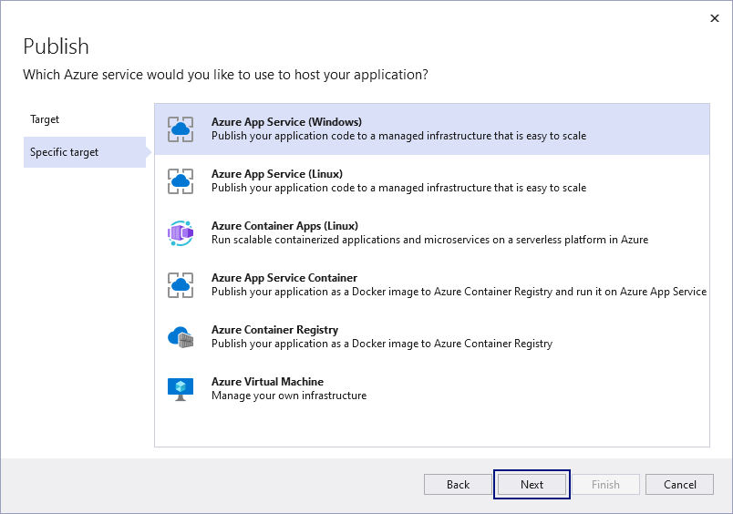

You may be asked to sign in with you account. In that case, click on the **[Sign in]** option:

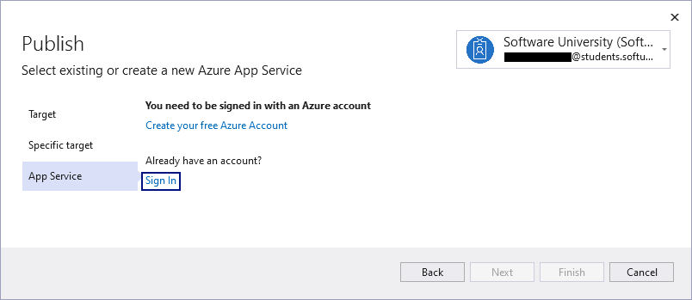

After you have signed in with your account, you have to choose a **Subscription name** and then click on the **[Create a new] to create a new app service.**

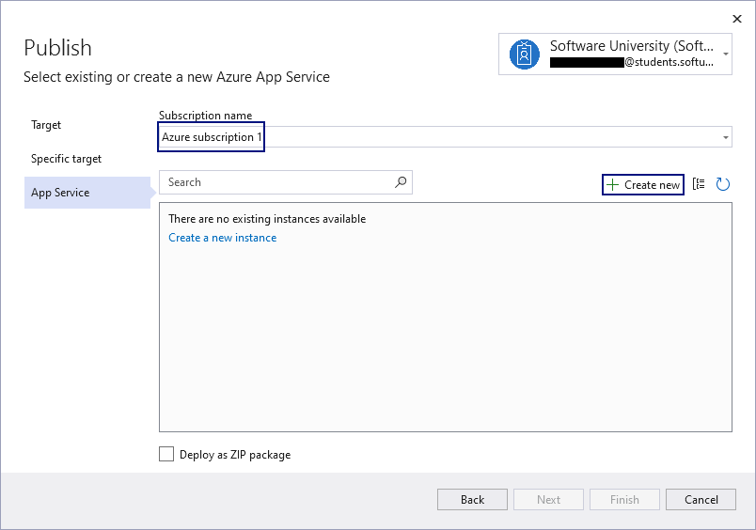

Now, you can choose a **Resource** **group** and **Hosting plan.** On the screenshot below you see the ones chosen by default.

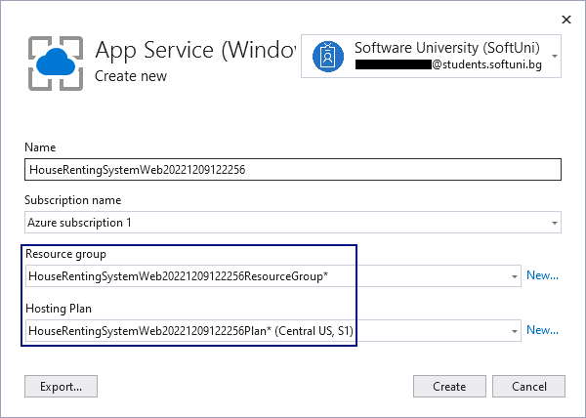

Click on the **[New]** button and create a new **Resource** **group**.

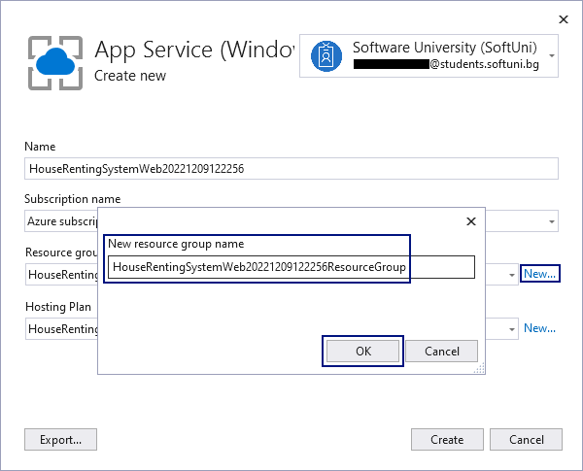

Take a look at the **Hosting Plan**. You can choose **Location** of the hosting and **Size** according to the objectives of your project.

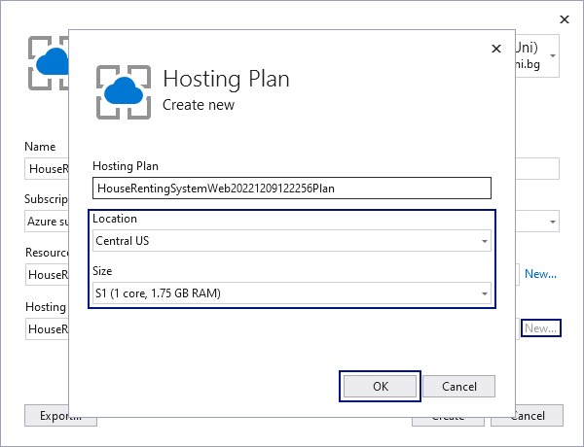

Now you are ready to create the **App Service** – just click on the **[Create]** button.

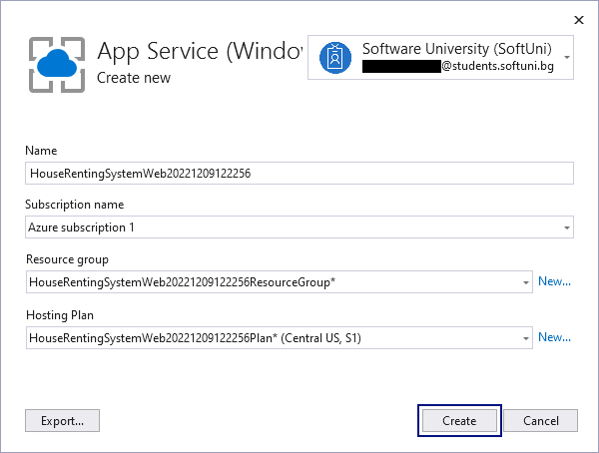

In the next window you should only click on the **[Finish]** button.

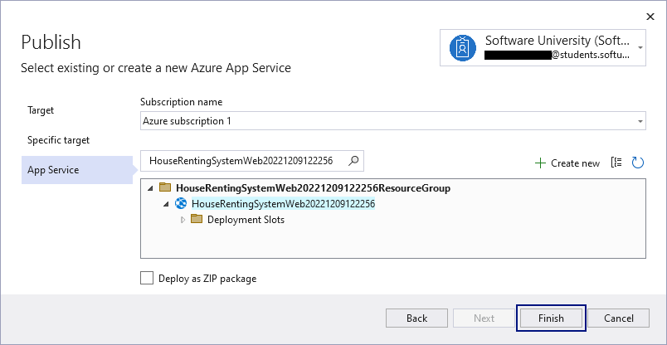

Next click on the **[Close]** button.

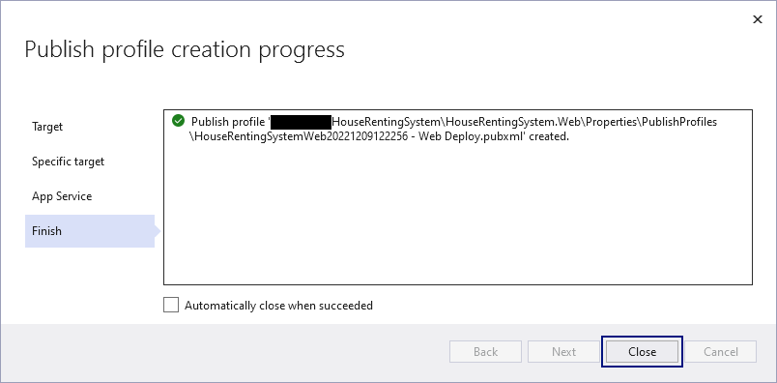

### Step 2: Configure Database

Next step is to **configure the database**. Press the **meatballs menu** (the three dots menu) → **Connect**.

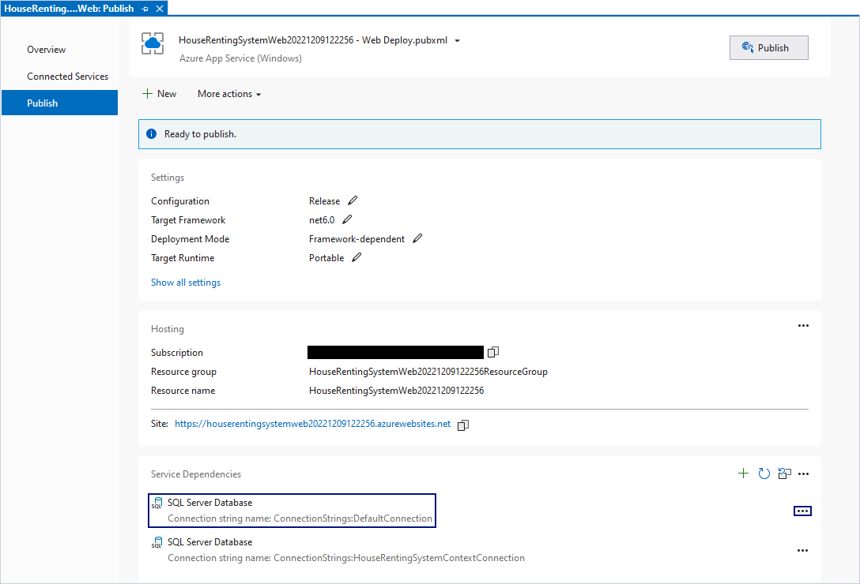

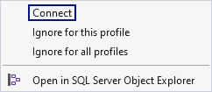

You can choose between **SQL Server** and **Azure SQL Databases**. For the purposes of this workshop, we will choose **Azure SQL Database**.

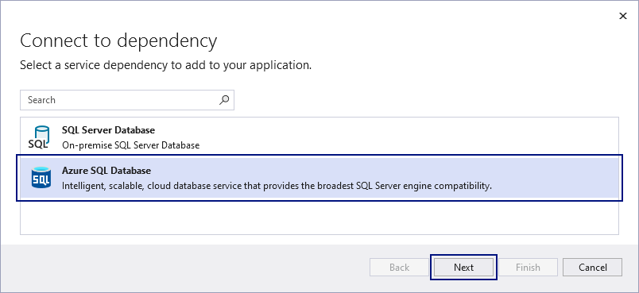

Next, we need to add a **Database**. Click on the [**Create New**] button.

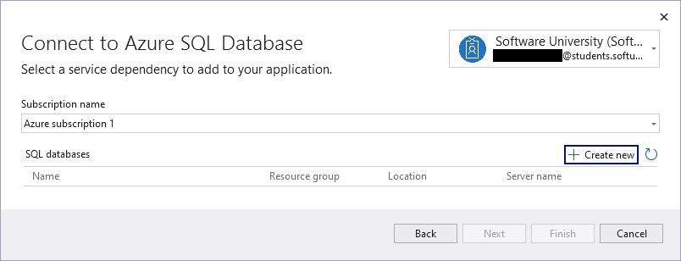

We need to add a **Server**:

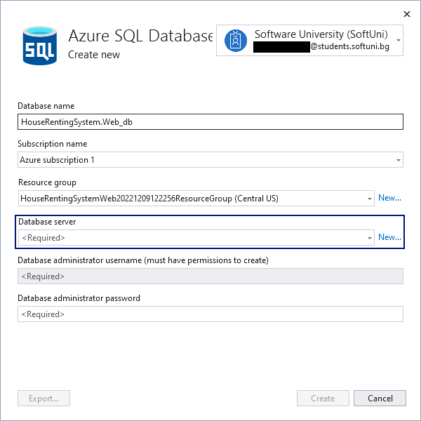

Add **Administrator's username** and **password** and click on the **[OK]** button

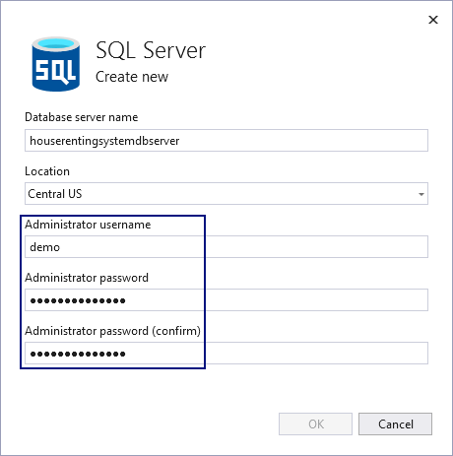

After that, click on the **[Create]** button.

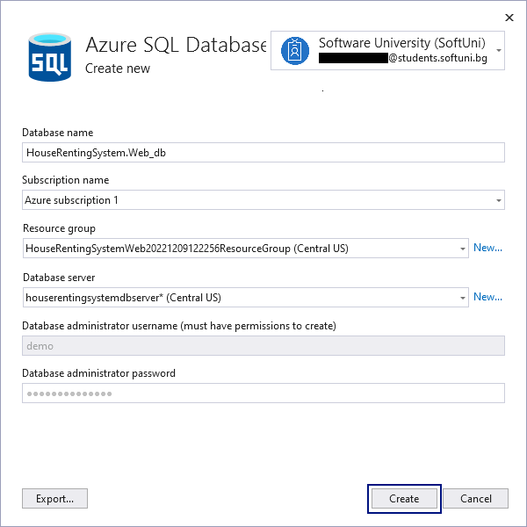

It may take several minutes before the **Azure SQL Database** is created. Don't worry – it's perfectly normal.

After the database is created, click on the **[Next]** button:

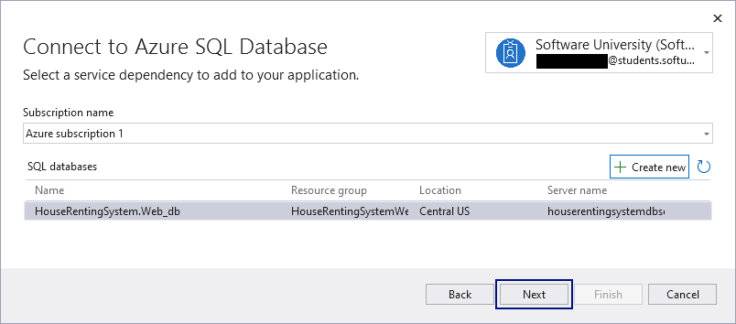

Now, you need to add a **Username** and a **password**.

It is **not** a good idea to use **administrator's name and password**. It is best to create a **User**. For **the purpose of this workshop** we will use administrator's name and password.

Click on the **[Next] button.**

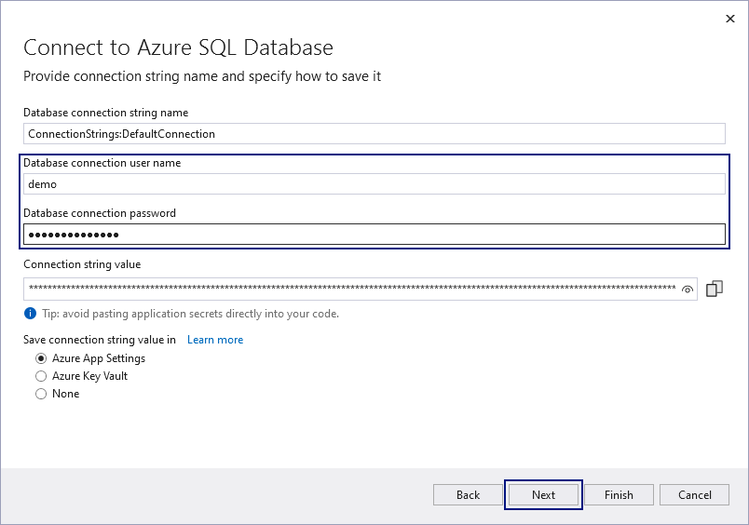

Click on the **[Finish]** button.

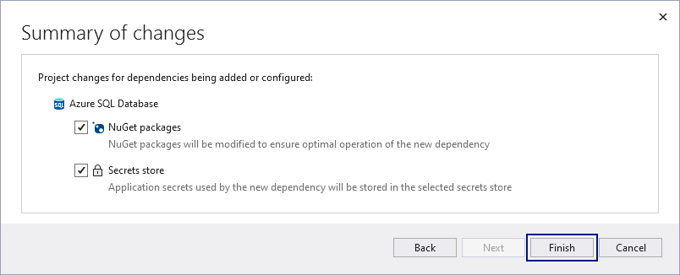

Now the **Database** is **connected** and you can continue with the deployment by pressing the **[Publish]** button.

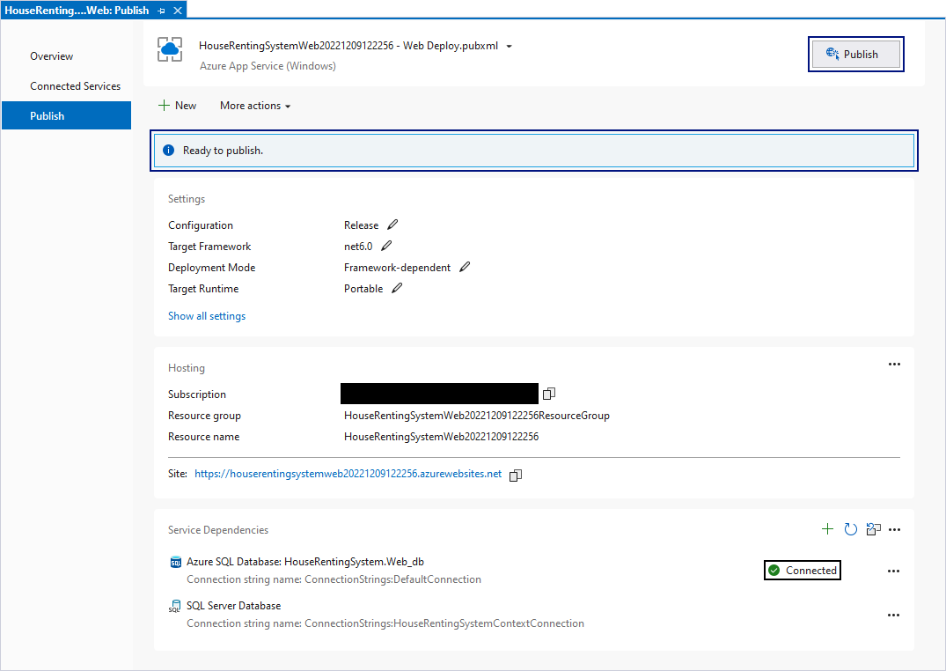

Publishing may take several minutes – it's normal. Upon successful publishing, you should see the message below:

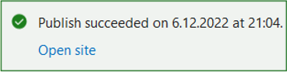

Congratulations! You have successfully published your first web app! 😊